[ART: FOOK! BOX COVER]

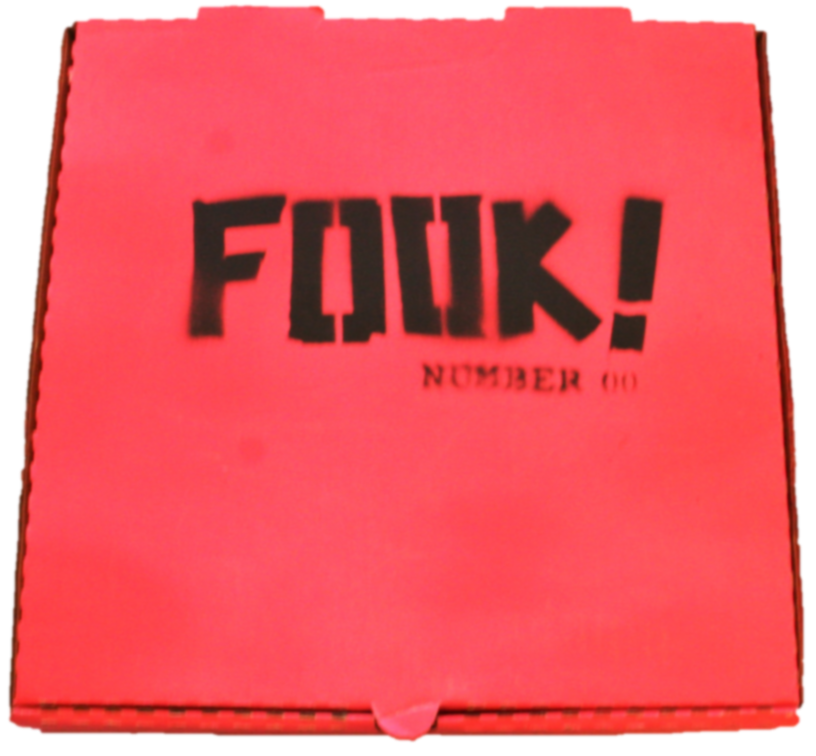

[Headline – H1]
FOR SALE

[Body copy]
FOOK! Number 00 prototype limited edition of 20, housed in hot-pink pizza box (12”x12”x2”): $850

Some individual items are also available.

[CTA 1]
DOWNLOAD THE CATALOGUE <link to: catalogue>

[CTA 2]
DOWNLOAD THE PRICE LIST <link to: pricelist>

