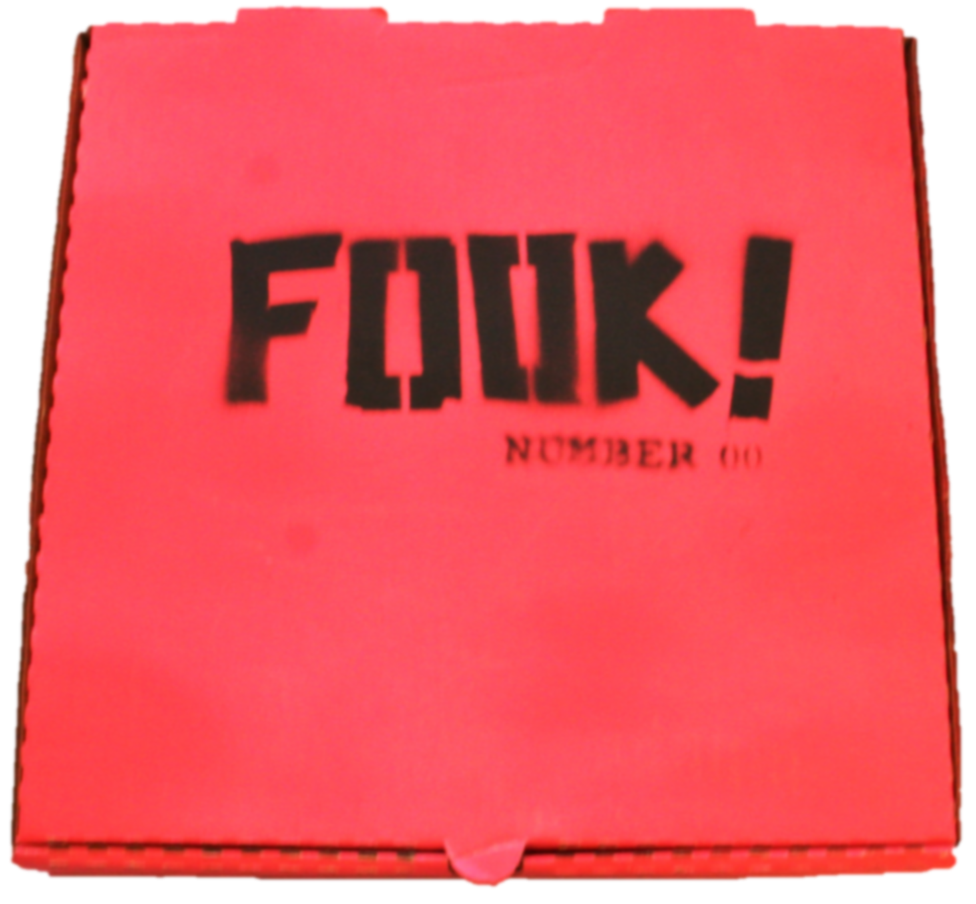

FOR SALE

FOOK! Number 00 prototype limited edition of 20, housed in hot-pink pizza box (12”x12”x2”): $850

Some individual items are also available.

DOWNLOAD THE CATALOGUE DOWNLOAD THE PRICE LIST

